8 The Navigation Sass Code

<https://www.youtube.com/watch?v=_a5j7KoflTs>

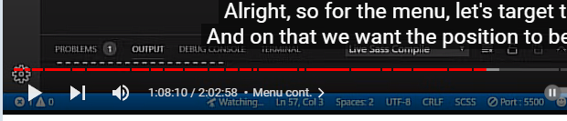

# Turn on Sass

In Visual Studio

Remember to turn on your Watch Sass



Inside the main.scss

We will be making changes to our navigation, so the original code that we wrote in the main.scss will no longer be needed. You can just comment it out for now.

Your menu is looking like this now without the code commented out.

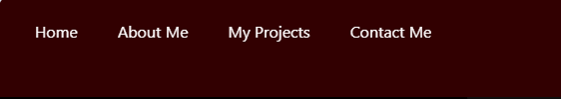

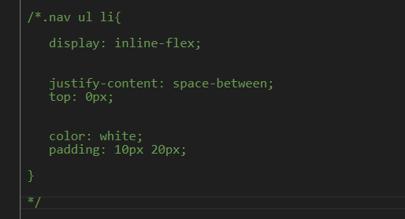

Your menu will now appear ugly and like this when the code is commented out.

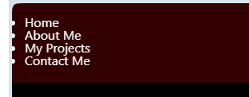

Inside of the _menu.scss file

# The .nav Class

You want to create a new nav Class. Inside of the _menu.scss file, go to the very last closing curly brace on the page, you will be creating this new class there.

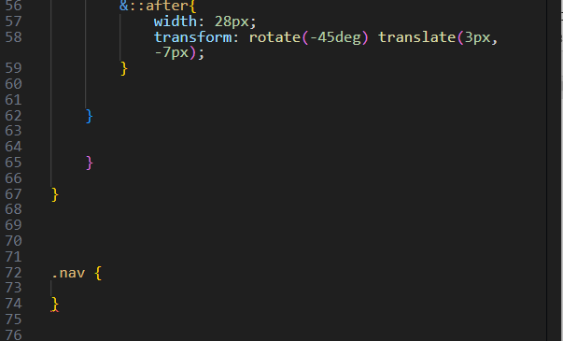

In this next code, you will see we will be making the vw to be 100vw, which makes it 100% of the viewport width. The opacity set to 0.98 will only allow us to see just a hint of it on the screen. We set the translateY to be a -100 %. This means that our menu has been moved upward and off the screen.

.nav {

position: fixed;

top: 0;

left: 0;

width: 100vw;

opacity: 0.98;

visibility: hidden;

&.open {

visibility: visible;

}

.menu-nav {

display: flex;

flex-flow: column wrap;

align-items: center;

justify-content: center;

height: 100vh;

overflow: hidden;

background: $primary-color;

list-style-type: none;

padding-right: 1rem;

transform: translateY(-100%);

@include transition-ease;

}

}

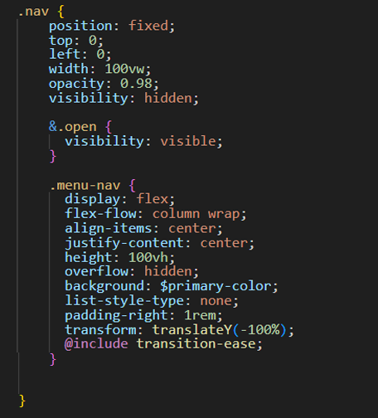

*Remember when you test it, you must be on the index.html page, or you will only get gobbety-gook on the screen.

Yes, you will not see the menu, because it is starting out at a position, which is moved upward and off the screen.



Now to write the code to move the menu down ward.

&.open {

transform: translateY(0);

}

*Warning, now do not expect this code to do anything yet. We need to write the Java Script first in the Java Script file.

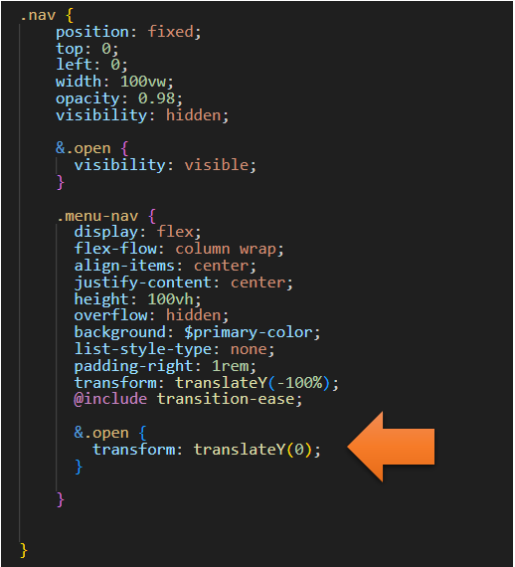

# The Java Script for the Nav Menu

Go to your main.js file, which is inside of your dist folder.

Write another Two constants at top

const nav = document.querySelector('.nav');

const menuNav = document.querySelector('.menu-nav');

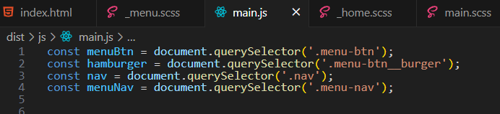

Changes to the function toggleMenu

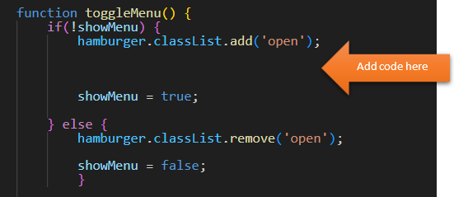

nav.classList.add('open');

menuNav.classList.add('open');

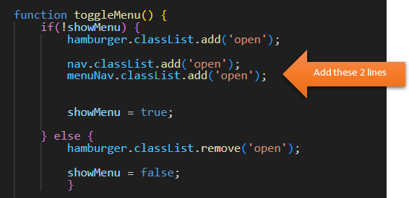

Now copy those two lines of code, because we need to do the same thing after the else clause when we remove it.

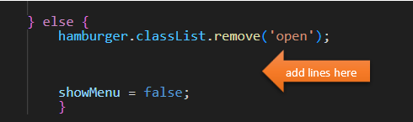

You will need to change the word add to remove in both lines.

nav.classList.remove('open');

menuNav.classList.remove('open');

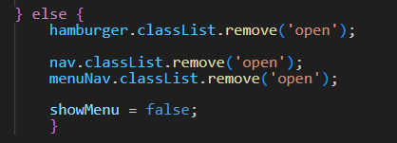

const menuBtn = document.querySelector('.menu-btn');

const hamburger = document.querySelector('.menu-btn__burger');

const nav = document.querySelector('.nav');

const menuNav = document.querySelector('.menu-nav');

let showMenu = false;

menuBtn.addEventListener('click', toggleMenu);

function toggleMenu() {

if(!showMenu) {

hamburger.classList.add('open');

nav.classList.add('open');

menuNav.classList.add('open');

showMenu = true;

} else {

hamburger.classList.remove('open');

nav.classList.remove('open');

menuNav.classList.remove('open');

showMenu = false;

}

}

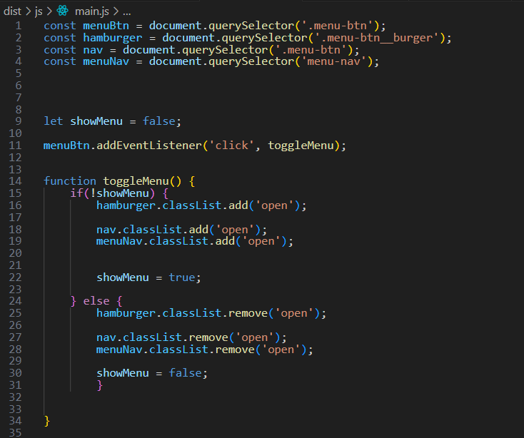

# Testing the Page

Make sure you go back to the index.html page to test the code out.

This is what the page looks like when you first arrive.



Click on the Hamburger button

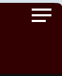

Now your menu part comes down and covers the page and the page looks like this, with just a hint of the main home page showing below

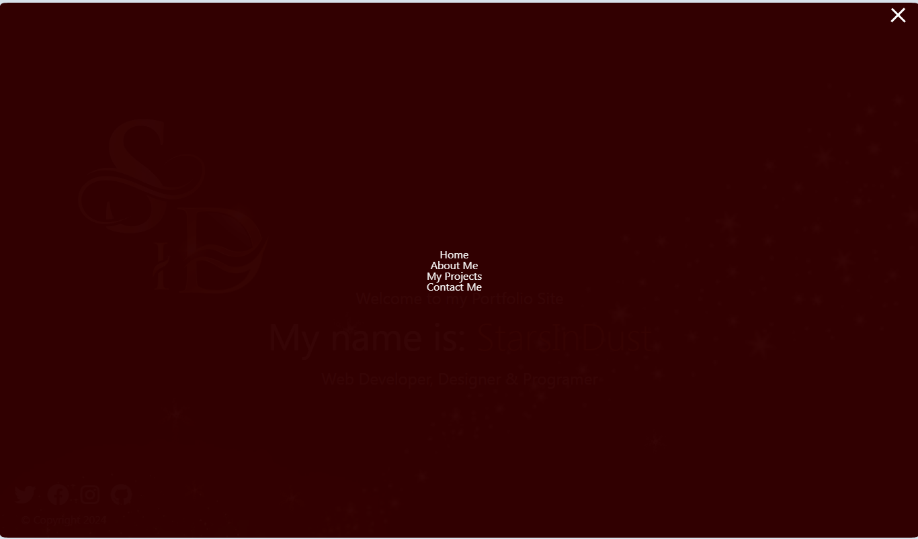

Click on that X again and it shows the home page again

